TEAM ID: PNT2022TMID28841

PROJECT NAME: DemandEst - AI powered Food DemandForecaster

Team Leader

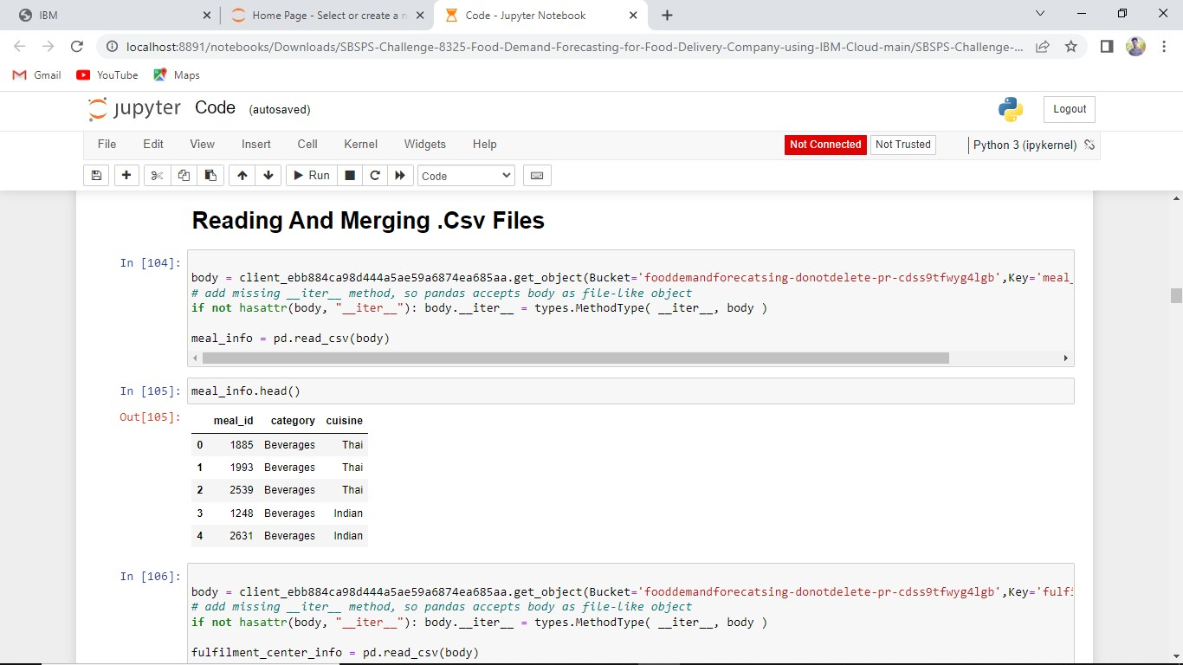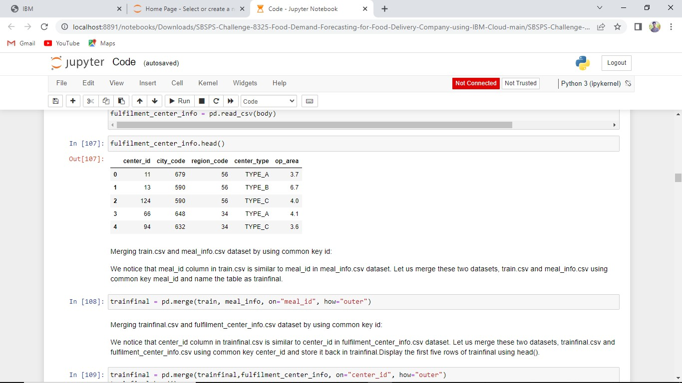

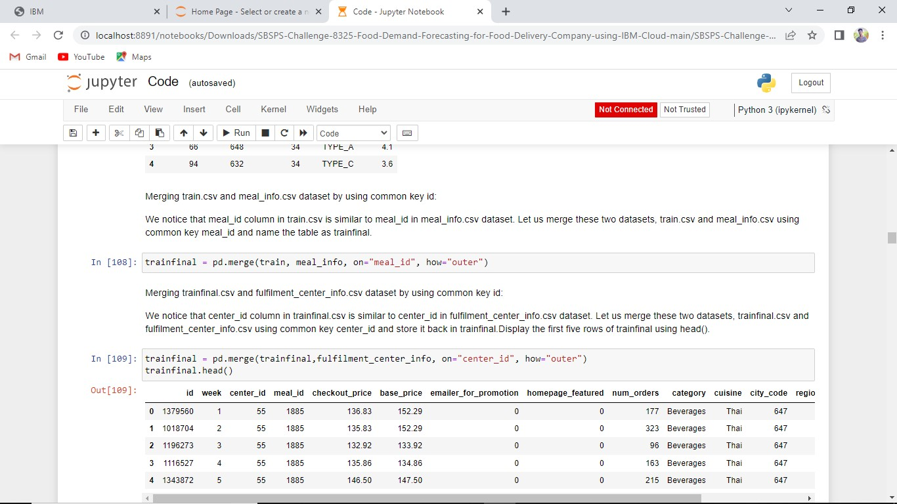

# Team Member 1







# Team Member 2







# Team Member 3





